There are 3 ways to use the function in the math library

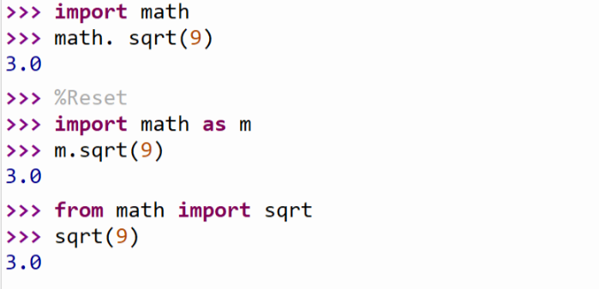

The third way: import sqrt function only

sqrt does not need a reference

%Reset means that it stops all the statements in the shells and starts again

You can use tab to check all the functions in the math library.

Math library

Pi: an approximation of pi

e: an approximation of e

sqrt(x): the square root of x

sin(x): the sine of x

cos(x): the cosine of x

tan(x): the tangent of x

asin(x): it is arctan(x), which is the inverse of sine x

acos(x): it is arccos(x), which is the inverse of cos x

atan(x): it is arctan(x), which is the inverse of tan x

log(x): it is ln(x), which is the natural (base e) logarithm of x

log10(x): it is log10(x), which is common (base 10) logarithm of x

exp(x): the exponential of x

ceil(x): the smallest whole number >= x

floor(x): the largest number whole number <= x

